worksheet 6: task to be introduced by the teacher to the whole class
Resources: see below
Grouping: 
Focus on content: mathematics
Focus on language: English
“In many ancient societies numbers used to be represented in a symbolic way, e.g. by pictures or colors
- the Egyptians used “red auxiliaries” to help them solve problems in arithmetic
- the Chinese used red color for positive numbers, and black for negative numbers
Have you noticed the symbols in the top right-hand corner of your worksheets? Each of them represents a number:”
(Now the teacher should write the following table on the board.)






1 4 7

2 5 8


3 6 9

Task:
“Is there a system for easily remembering these symbols without memorizing? You can discuss it in pairs or you can come up with suggestions right now.”
Answer sheet:
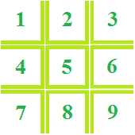

References:
Joseph, G.G. The Crest of the Peacock, London: Penguin Books Ltd., 2000.

